**Principles of Cloud Computing**

**Name: Tejas Rahul Rokade**

**Reg. No.: 20BDS0033**

**Lab 3**

**Question 1 - Launching a Web App onto EC2**

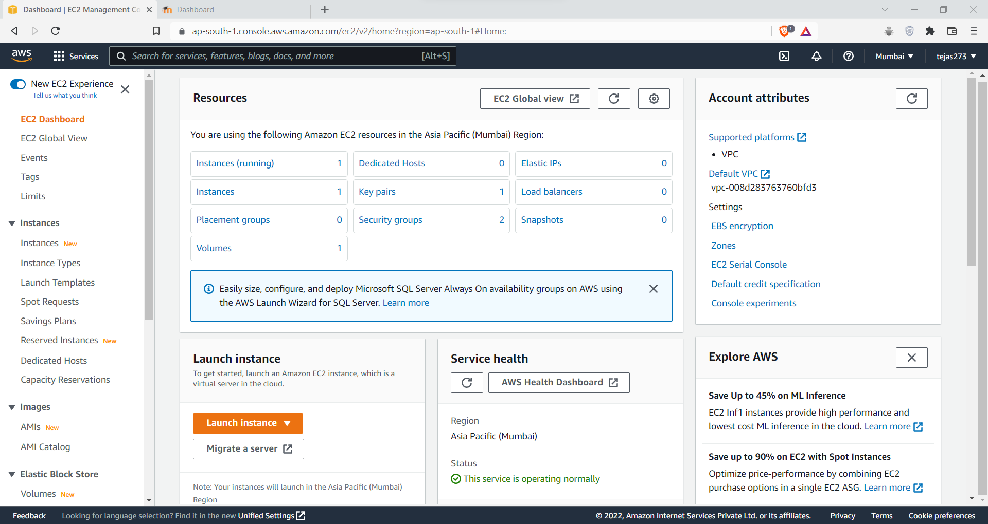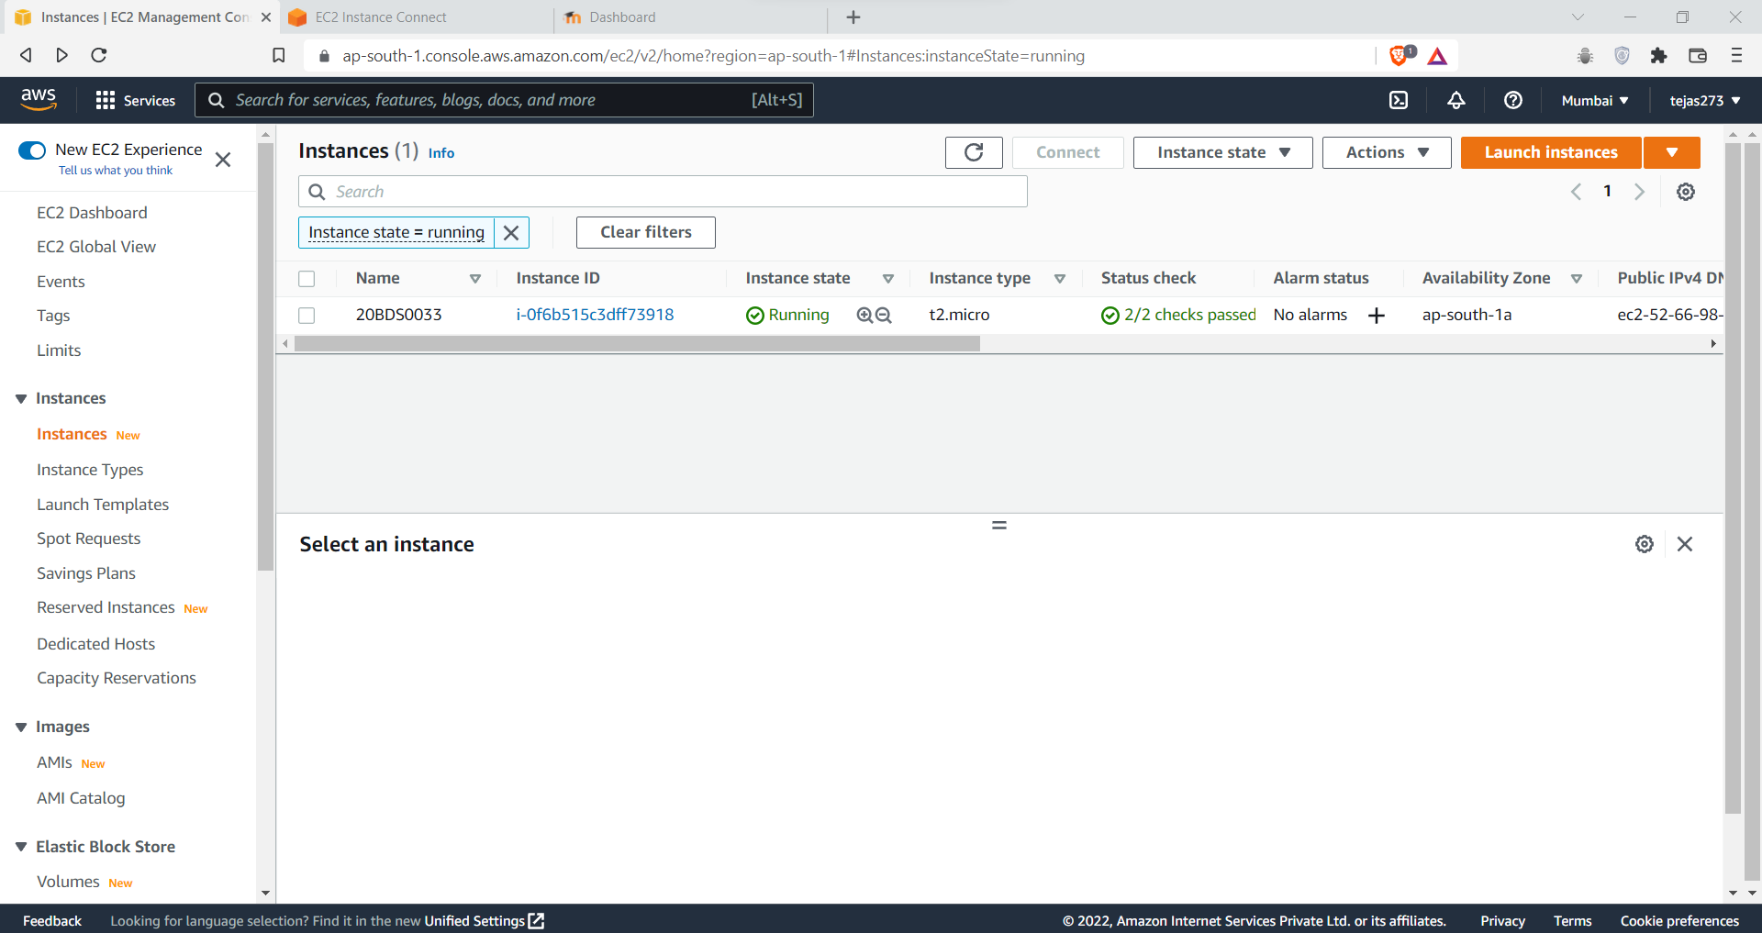

Click Instance Summary

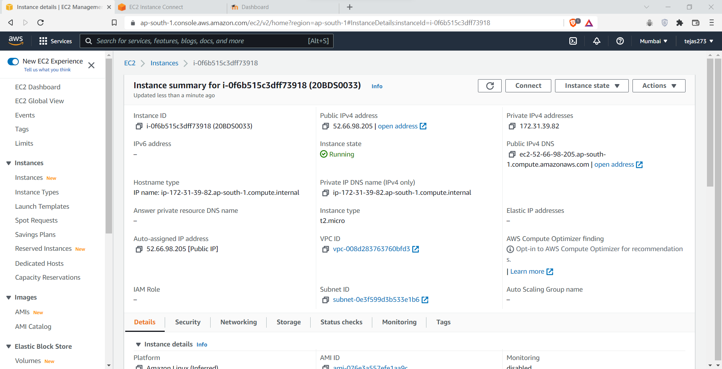

Go to security then go to security groups

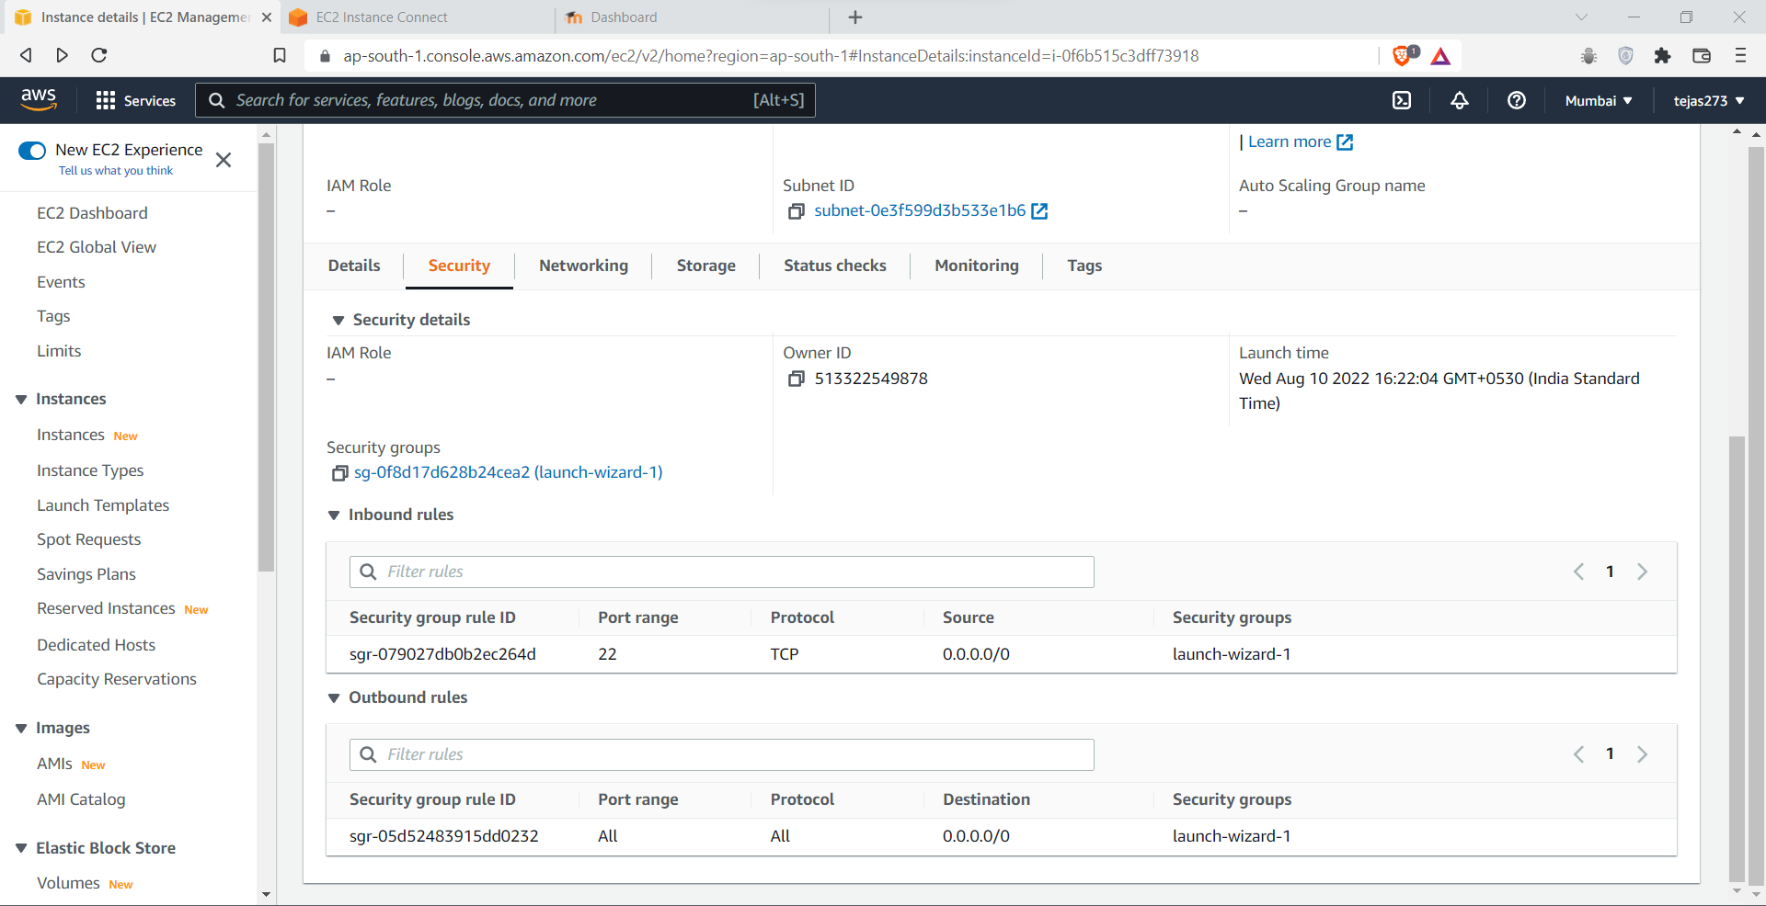

Click on actions drop down then choose edit inbound rules

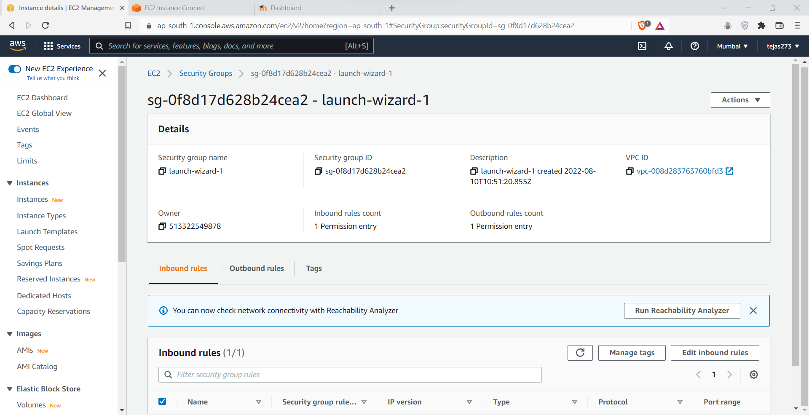

Click on add rule and In type dropdown choose http and save rules

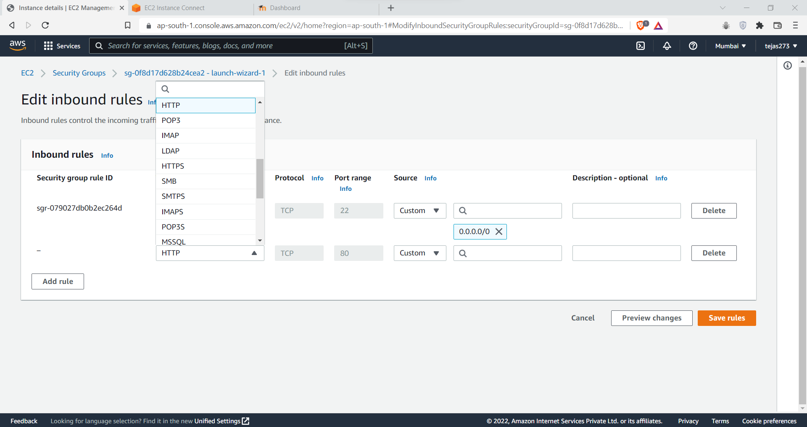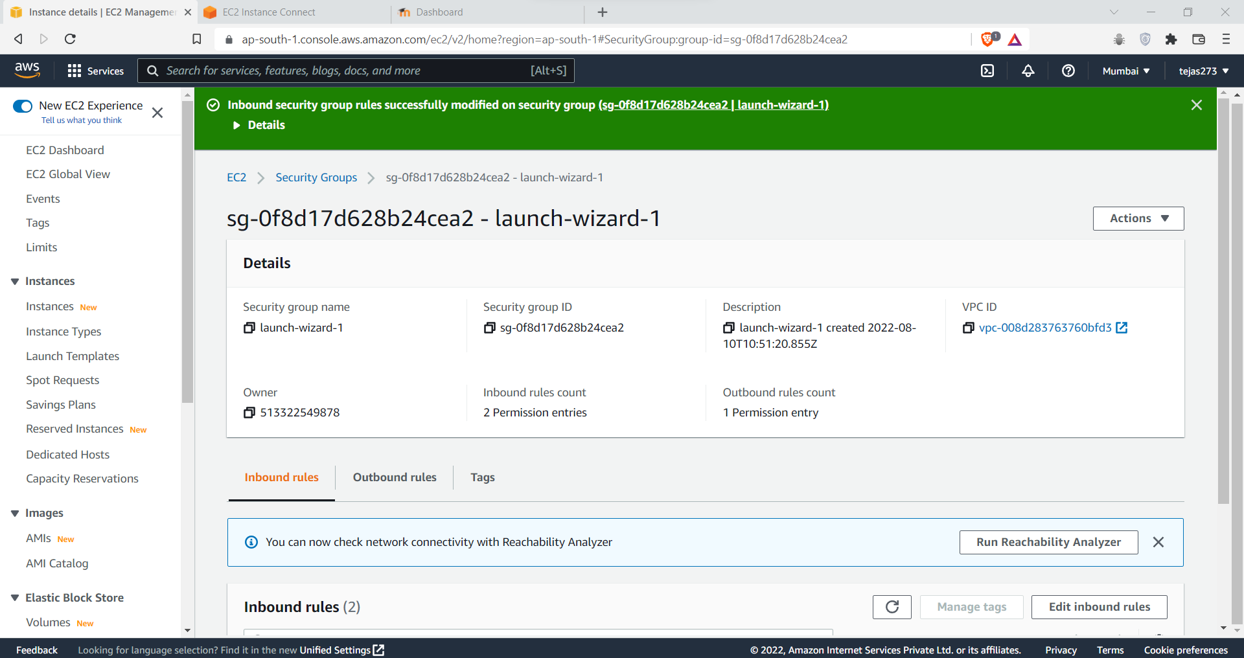

Now connect to the ec2 instance to Ubuntu (ssh) as done in previous experiment

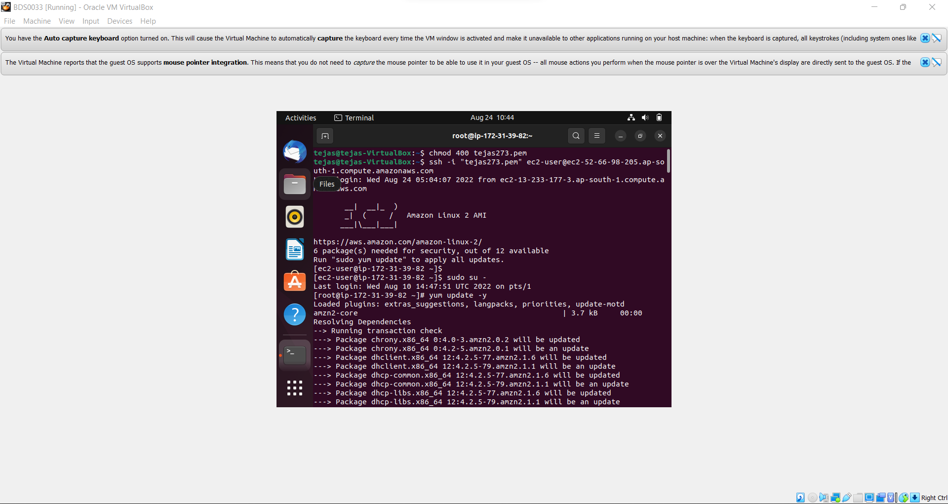

In terminal type yum install httpd –y

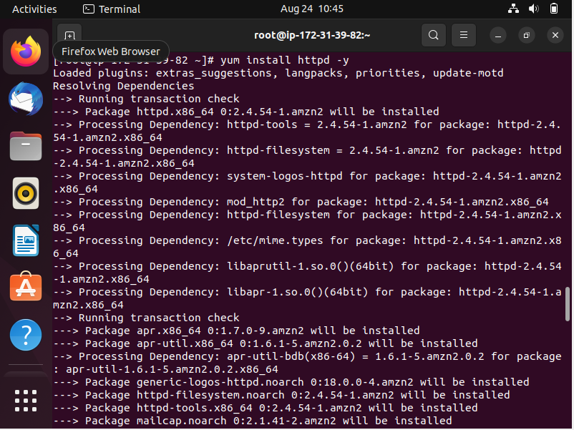

Create file index.html

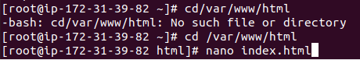

Index.html

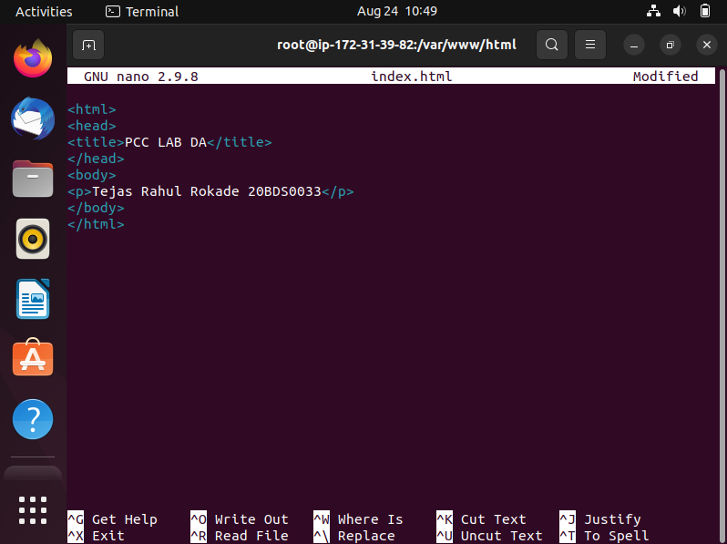

After creating the file index.html

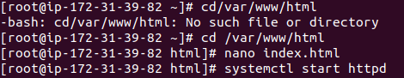

Go to the browser window and type http://<ipadress of ec2>/index.html

In my case it is <http://52.66.98.205/index.html>

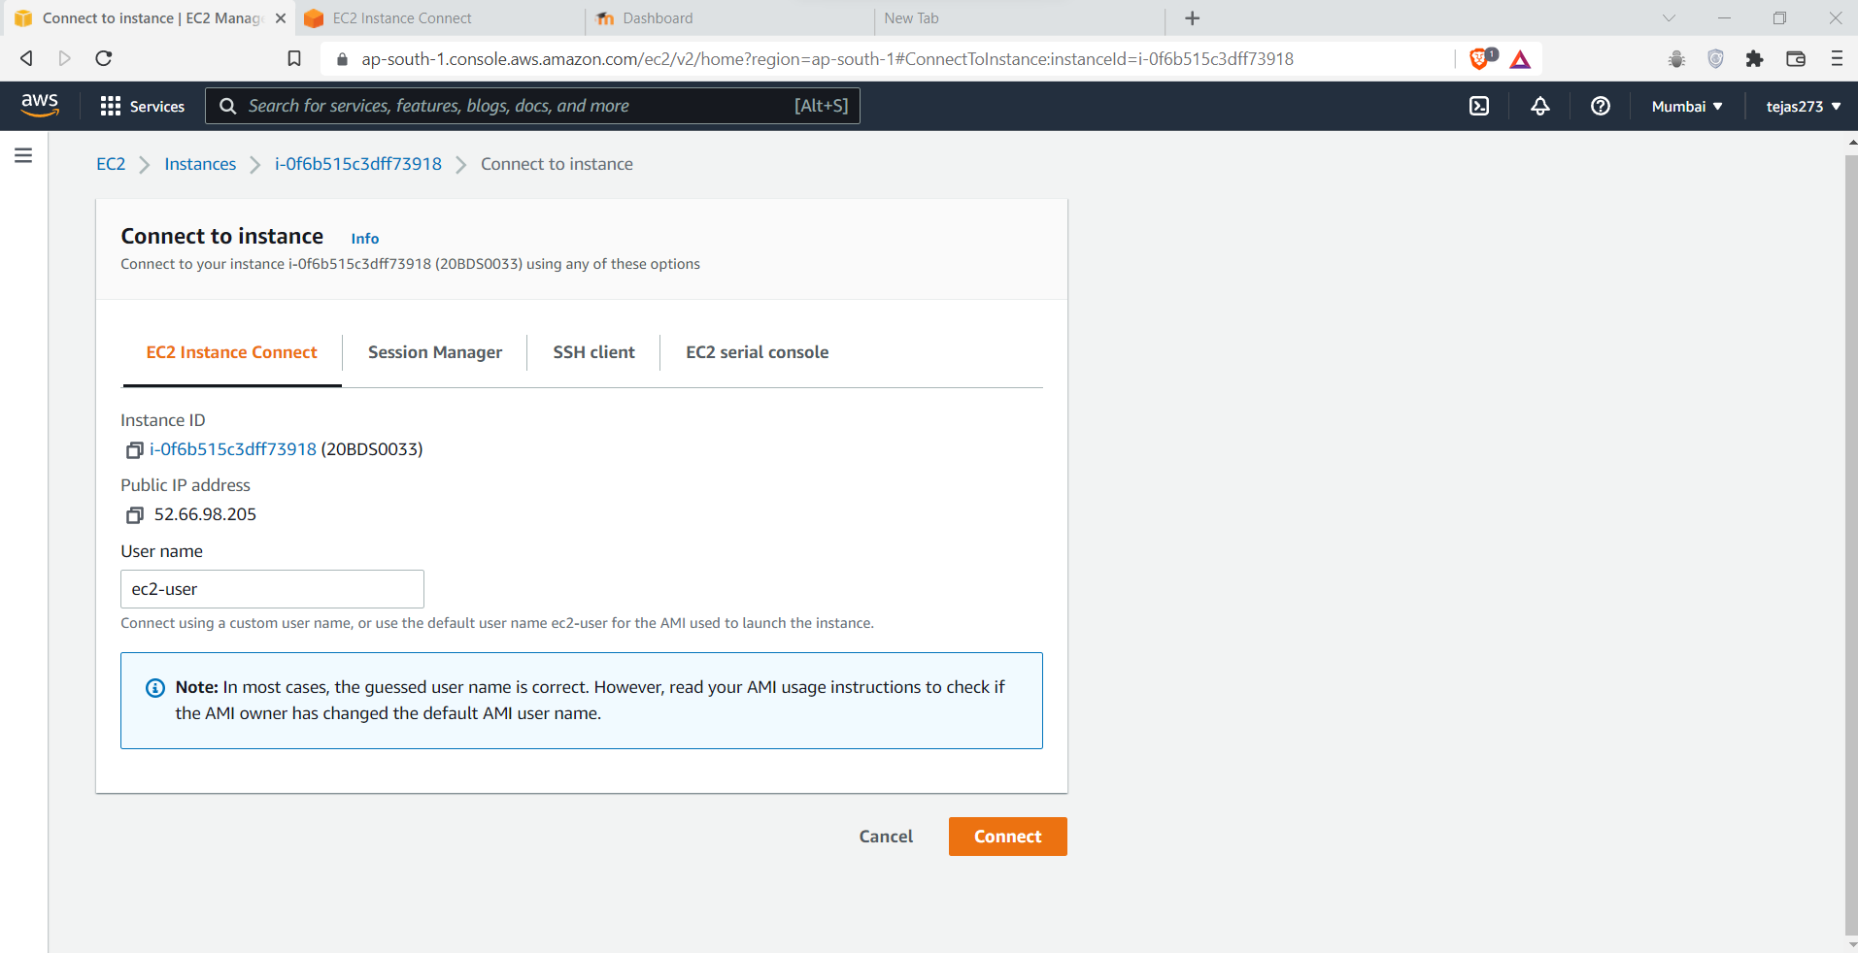

Output

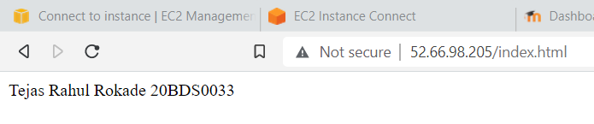

**Question 2**

**Go to freewebistetemplates.com and download a template**

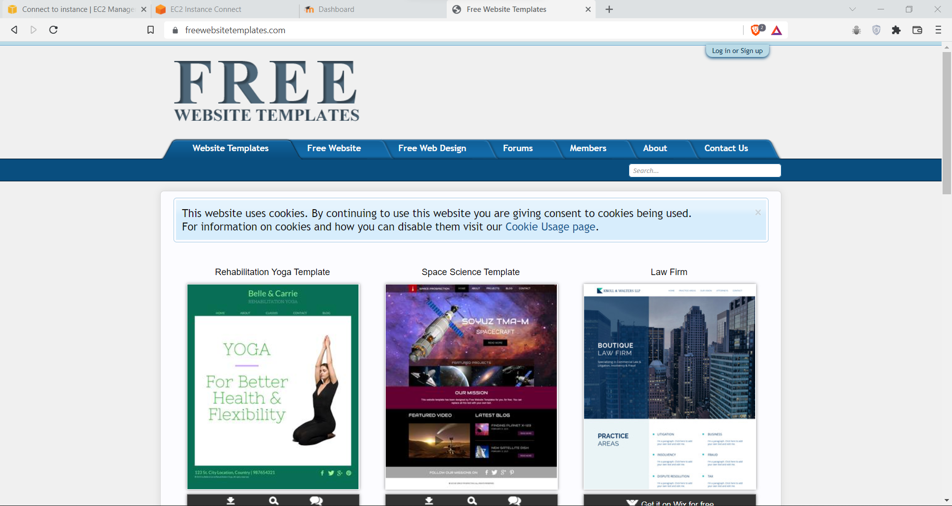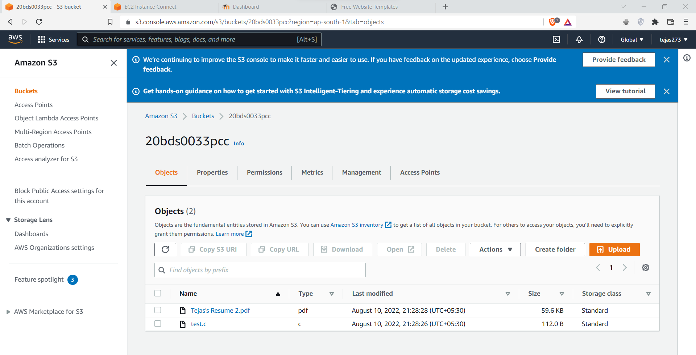

Upload the zip file into the s3 bucket

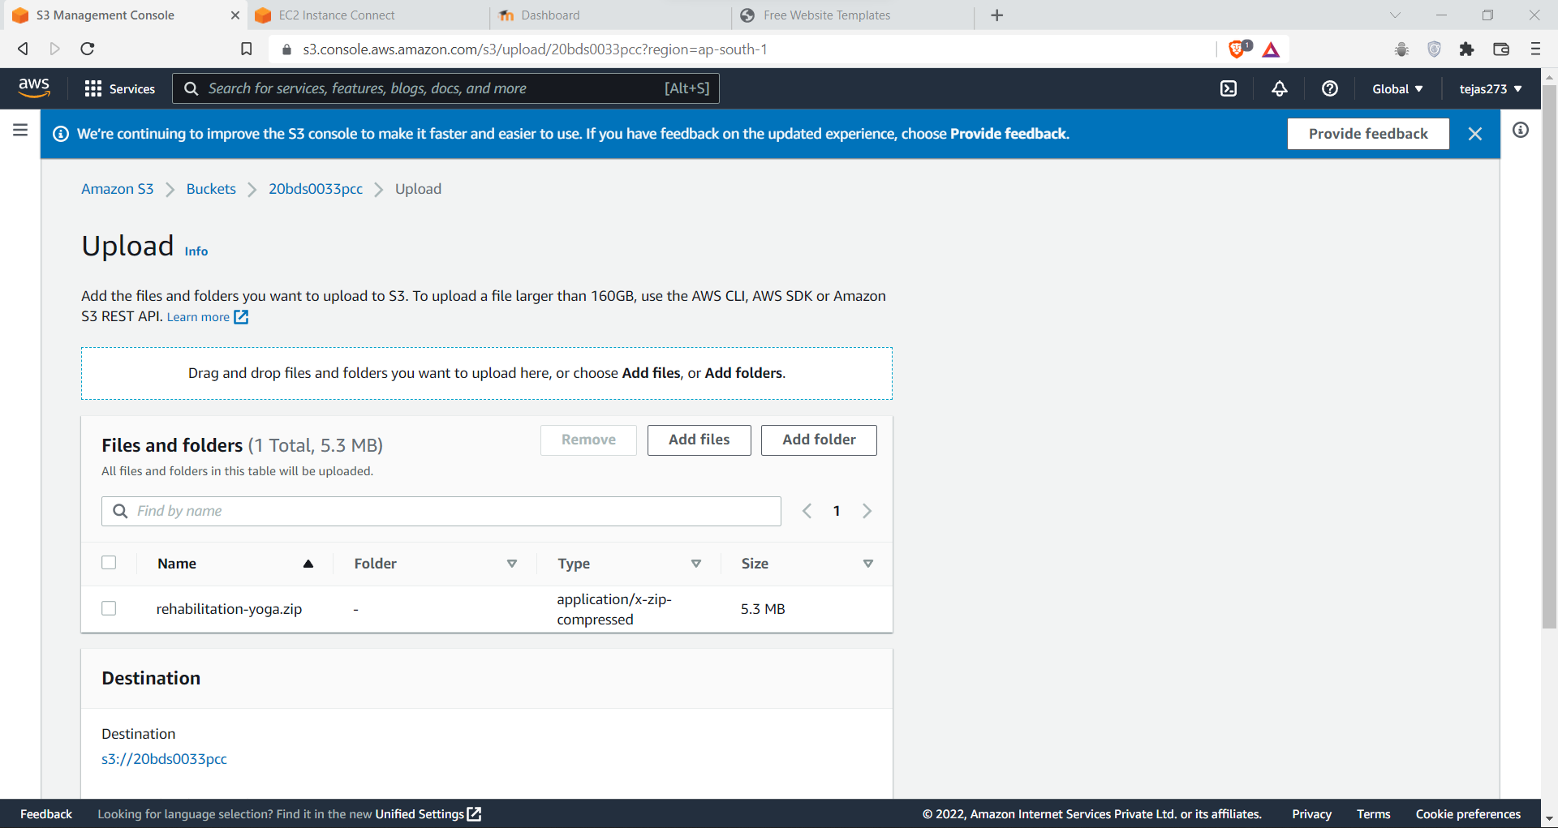

Upload Success

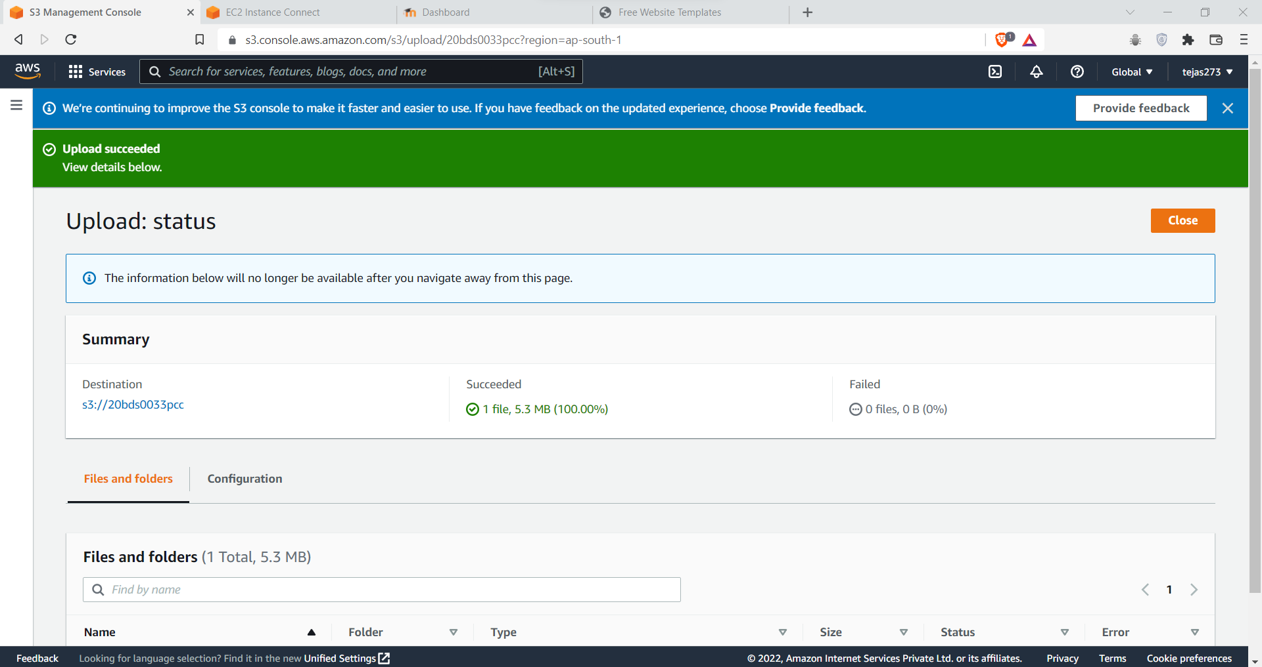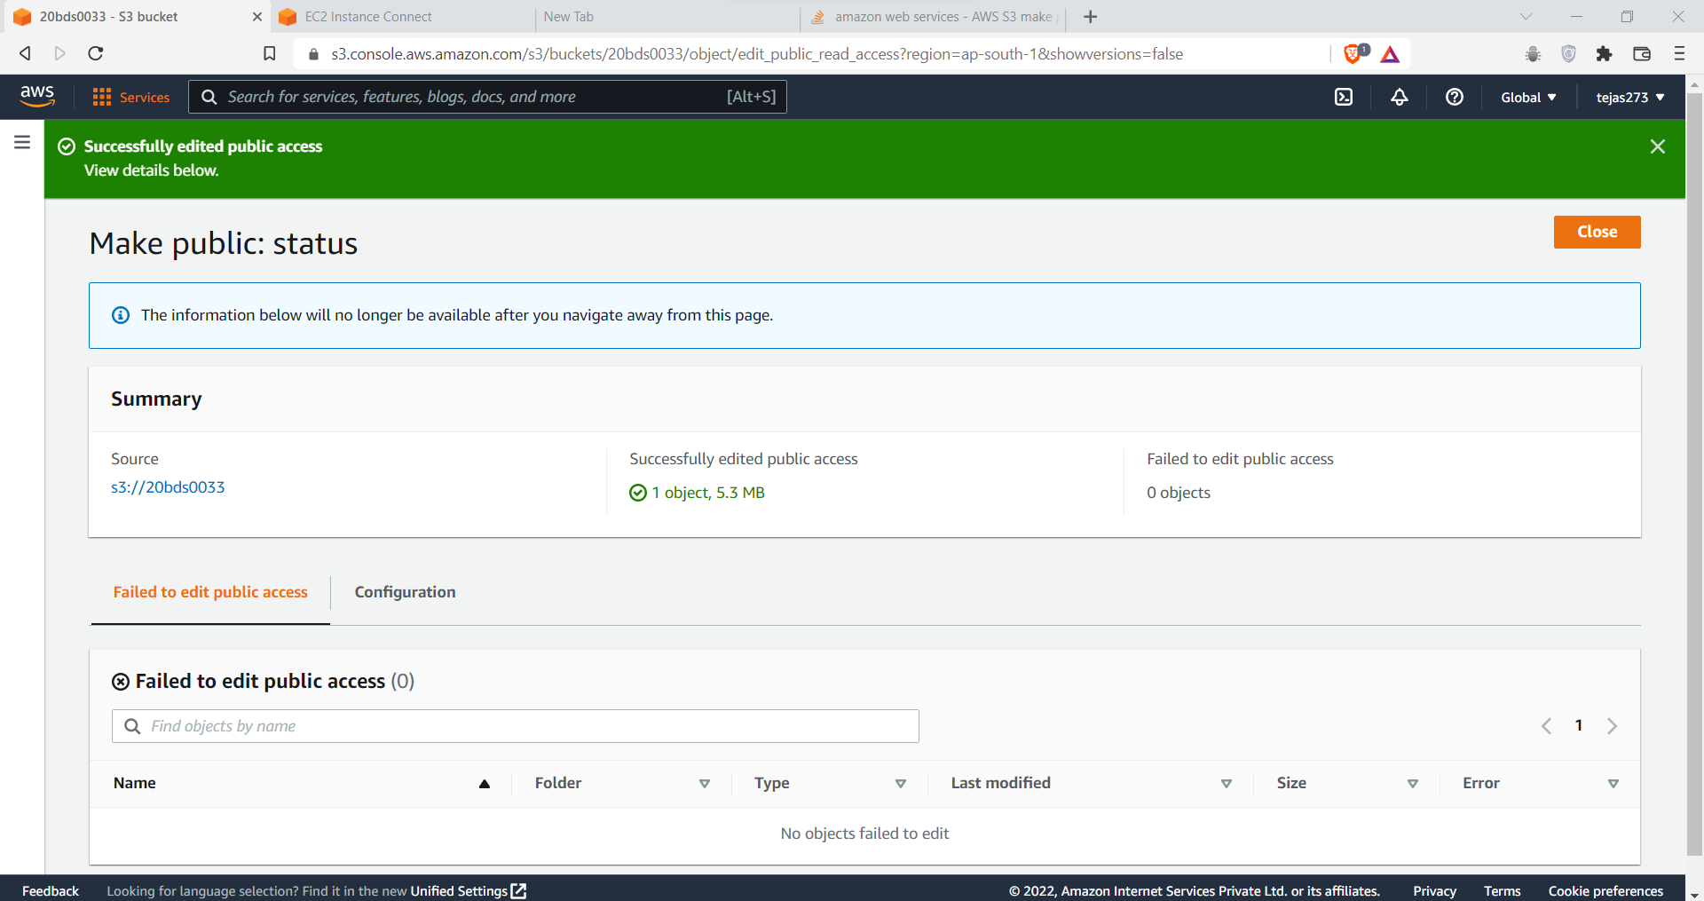

Download the Zip file from S3 Bucket into /var/www/html

throgh running

sudo wget http://3.110.132.67/rehabilitation-yoga/upload/blog.html

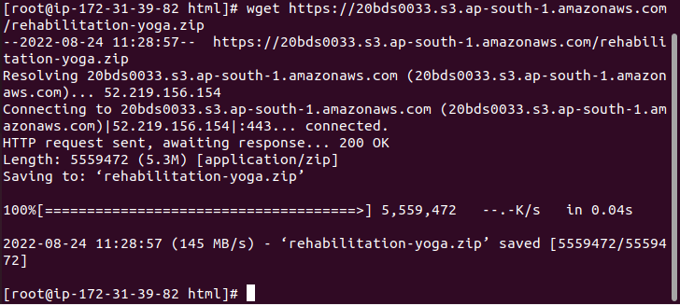

Unzip the zip file

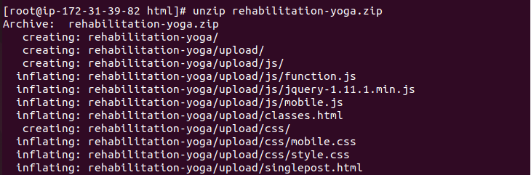

Renaming the zip file



Output

